The SneaKeyBoard HowTo

How to edit the [sneakeyboard](https://github.com/haxcess/sneakeyboard)

## Set up Arduino environment (mac/linux/windows):

1. Get some digisparks (search for attiny85 or digispark)
2. [Download Arduino](https://www.arduino.cc/en/Main/OldSoftwareReleases#previous) 1.6.5
3. Add the digistump board library to Arduino (http://digistump.com/package_digistump_index.json)  
   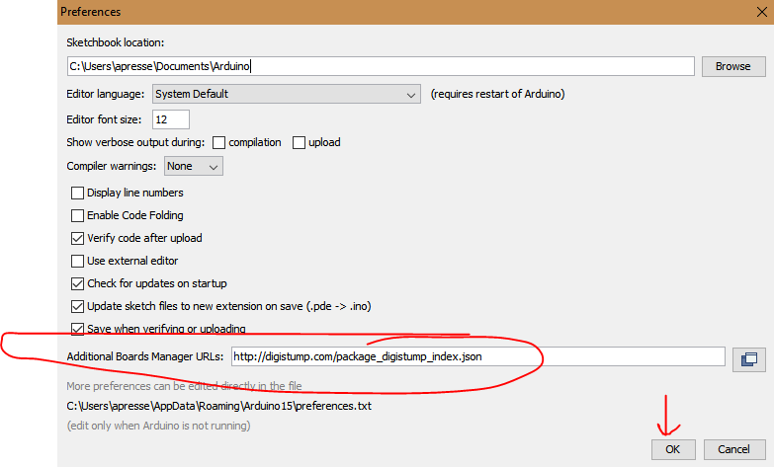
4. Add the FastLED library to Arduino (<https://github.com/FastLED/FastLED>)
   1. Sketch > Include Library > Manage Libraries  
      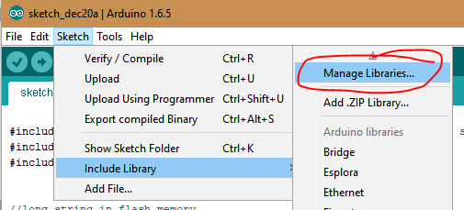
   2. Search for FastLED
   3. Install   
      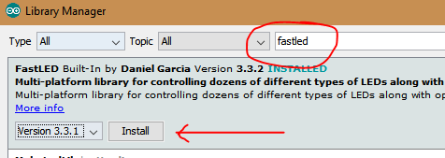
5. Restart Arduino studio

## Making a SneaKeyBoard

1. Download the sneakeyboard code from <https://raw.githubusercontent.com/haxcess/sneakeyboard/master/sketch_dec20a.ino>
2. Paste this into a new project
3. Edit the code, hit upload

